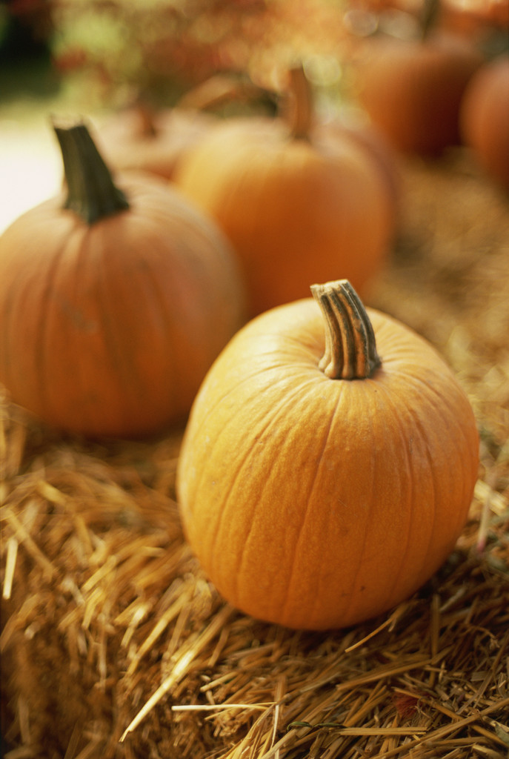
Mrs. Glaser’s Third Grade News
October 11, 2019

Dear Parents and Students,
What some nice weather we have been having! I really hate the dark and cold mornings so please dress in layers as the children are complaining they are cold outside for recess and the room is very chilly.

Please continue to work on your child’s addition and subtraction facts nightly. We do not work on basic addition and subtraction as our focus is on multiplication.
Continue to work on the multiplication and division facts nightly as these are expected to be mastered by the end of third grade and that is why we are starting multiplication and division so early. I am sending home a skills sheet with multiplication and division nightly. This week we worked on 3’s and continued reviewing the 0. 1, 2, 5, and 9’s. I am seeing some great progress!

Every night your child will have reading, math and spelling to do. Please check that they have done their work as some have been coming to school with their assignment books not signed and they did not do their reading or math for the night. A sheet will be given daily at school for spelling to help your child improve their cursive and to practice writing their spelling words correctly. Often children can spell them out loud correctly by telling you the letters, but when it comes to putting it on paper they forget or add letters.

We are working on the character trait of responsibility and how they show it by doing what they are expected to do. Ask your child what they did at school each day to show they were being responsible. Last month we worked on respect.

Our theme in reading the next 4-5 weeks is traditions, so we will be discussing traditions we have and other traditions other areas have around the world. I can’t wait for the wonderful discussions we will have. Ask your child what they have discussed and learned about. We are currently reading a book titled, Snot Stew, written by Bill Wallace. We will be reading stories Patricia Polacco has written. Ask your child about the stories that I have read to them. Have them share with you what they learned about this author? Do not let them tell you nothing as they should be able to tell you at least 5 things if not more!

October 20st I will send home a conference time letter
October 31th Spooky Story Night 6:00 – 7:00
October 31th Black and Orange Day
Classroom Halloween Party Oct. 31

We will be having a Halloween Party on the 31st.
I am looking for a few people to bring treats!

